Sql Script
Name: Đinh Việt Quang
Student ID: 20215235

1. Entity relationship diagram
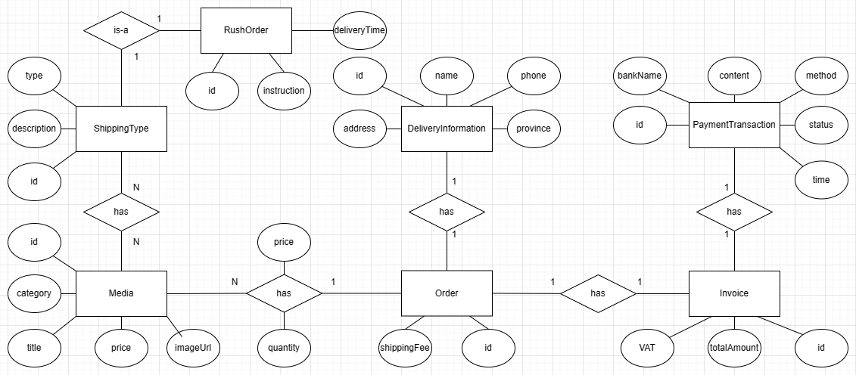

2. Database schema
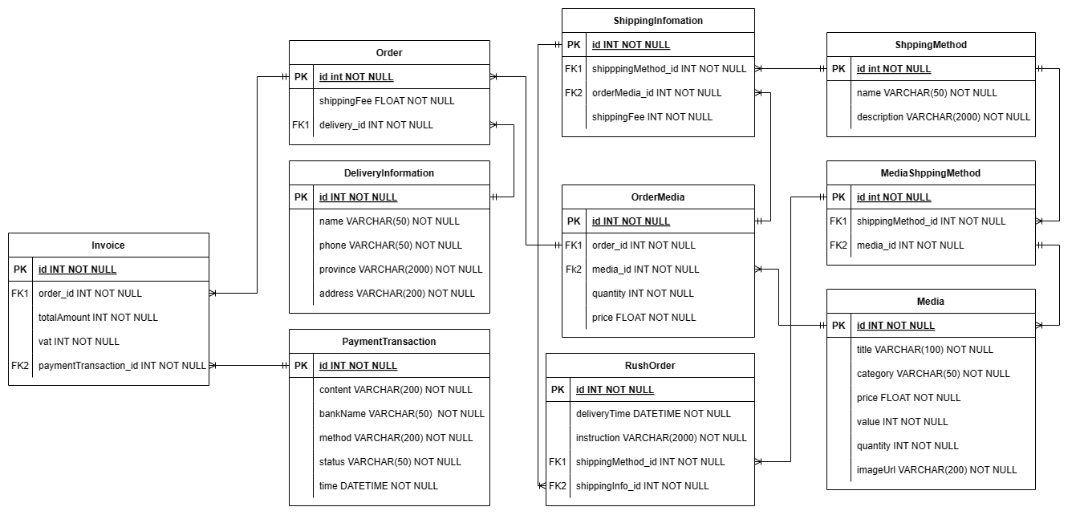

3. SQL script code
CREATE TABLE Media (
id INT NOT NULL,
title VARCHAR(100),
categoryType VARCHAR(50),
value INT NOT NULL,
price INT NOT NULL,
quantity INT,
imageURL VARCHAR(200)
);
ALTER TABLE Media
ADD CONSTRAINT PK_Media PRIMARY KEY (id);

CREATE TABLE PaymentTransaction (
id INT NOT NULL,
content VARCHAR(200) NOT NULL,
bankName VARCHAR(50) NOT NULL,
method VARCHAR(200) NOT NULL,
status VARCHAR(50) NOT NULL,
time DATETIME NOT NULL,
);
ALTER TABLE PaymentTransaction
ADD CONSTRAINT PK_PaymentTransaction PRIMARY KEY (id);

CREATE TABLE Invoice (
id INT NOT NULL,
order_id INT NOT NULL,
totalAmount INT NOT NULL,
vat INT NOT NULL,
paymentTransaction_id INT NOT NULL
);
ALTER TABLE Invoice
ADD CONSTRAINT PK_Invoice PRIMARY KEY (id);

CREATE TABLE Order (
id INT NOT NULL,
shippingFees FLOAT NOT NULL,
delivery_id INT NOT NULL
);
ALTER TABLE Order
ADD CONSTRAINT PK_Order PRIMARY KEY (id);

CREATE TABLE DeliveryInformation (
id INT NOT NULL,
name VARCHAR(50),
phone VARCHAR(50) NOT NULL,
province VARCHAR(2000) NOT NULL,
address VARCHAR(200) NOT NULL,
);
ALTER TABLE DeliveryInformation
ADD CONSTRAINT PK_DeliveryInformation PRIMARY KEY (id);

CREATE TABLE ShippingInfomation (
id INT NOT NULL,
shippingMethod_id INT NOT NULL,
orderMedia_id INT NOT NULL,
shippingFee INT NOT NULL
);
ALTER TABLE shippingInfomation
ADD CONSTRAINT PK_shippingInfomation PRIMARY KEY (id);

CREATE TABLE OrderMedia (
id INT NOT NULL,
order_id INT NOT NULL
media_id INT NOT NULL,
quantity INT NOT NULL,
price FLOAT NOT NULL
);
ALTER TABLE OrderMedia
ADD CONSTRAINT PK_OrderMedia PRIMARY KEY (id);

CREATE TABLE RushOrder (
id INT NOT NULL,
instruction VARCHAR(2000) NOT NULL,
deliveryTime DATETIME NOT NULL,
shippingInfo_id INT NOT NULL,
shippingMethod_id INT NOT NULL,
)
ALTER TABLE RushOrder
ADD CONSTRAINT PK_RushOrder PRIMARY KEY (id);

CREATE TABLE ShippingMethod (
id INT NOT NULL,
name VARCHAR(50) NOT NULL,
description VARCHAR(2000) NOT NULL,
);
ALTER TABLE ShippingMethod
ADD CONSTRAINT PK_ShippingMethod PRIMARY KEY (id);

CREATE TABLE MediaShippingMethod (
id INT NOT NULL,
shippingMethod_id INT NOT NULL,
media_id INT NOT NULL
);
ALTER TABLE MediaShippingMethod
ADD CONSTRAINT PK_MediaShippingMethod PRIMARY KEY (id);

ALTER TABLE MediaShippingMethod
ADD CONSTRAINT FK_MediaShippingMethod_0 FOREIGN KEY (media_id) REFERENCES Media (id);

ALTER TABLE MediaShippingMethod
ADD CONSTRAINT FK_MediaShippingMethod_1 FOREIGN KEY (shippingMethod_id) REFERENCES ShippingMethod (id);

ALTER TABLE Order
ADD CONSTRAINT FK_Order_0 FOREIGN KEY (deliveryAddress_id) REFERENCES DeliveryAddress (id);

ALTER TABLE OrderMedia
ADD CONSTRAINT FK_OrderMedia_0 FOREIGN KEY (media_id) REFERENCES Media (id);
ALTER TABLE OrderMedia
ADD CONSTRAINT FK_OrderMedia_1 FOREIGN KEY (order_id) REFERENCES Order (id);

ALTER TABLE ShippingInfomation
ADD CONSTRAINT FK_ShippingInfomation_0 FOREIGN KEY (orderMedia_id) REFERENCES OrderMedia (id);
ALTER TABLE ShippingInfomation
ADD CONSTRAINT FK_ShippingInfomation_1 FOREIGN KEY (shippingMethod_id) REFERENCES ShippingMethod (id);

ALTER TABLE RushOrder
ADD CONSTRAINT FK_RushOrder_0 FOREIGN KEY (shippingInfo_id) REFERENCES ShippingInfomation (id);

ALTER TABLE RushOrder
ADD CONSTRAINT FK_RushOrder_1 FOREIGN KEY (shippingMethod_id) REFERENCES ShippingMethod (id);

ALTER TABLE Invoice
ADD CONSTRAINT FK_Invoice_0 FOREIGN KEY (order_id) REFERENCES Order (id);
ALTER TABLE Invoice
ADD CONSTRAINT FK_Invoice_1 FOREIGN KEY (paymentTransaction_id) REFERENCES PaymentTransaction (id);

